Official league roster – Soccer 2022
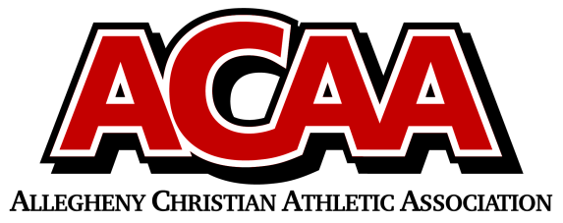
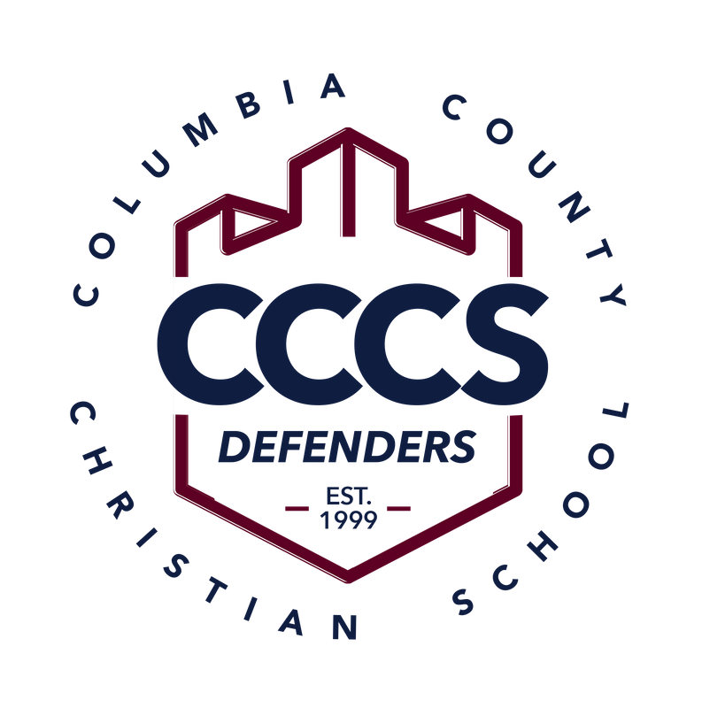

School Name: Columbia County Christian School
Team Colors: Navy Blue and White
Overall Wins ___ Losses ____ Ties ___
ACAA Wins ___ Losses ____ Ties ___ OPPONENT: __________________________
Date: _________
Number | Name | Year | Position | Homeschool
11 | Kara Boudman | 12 | Mid
7 | Hazlee Bialecki | 12 | Defender
14 | Lydia Speaks | 12 | Defender
6 | Gracie Clippinger | 11 | Forward
13 | Morgan Perry | 11 | For/Def
12 | Ava DiLena | 11 | Mid
20/28 | Kearsten Derr | 11 | Mid/Goalie
2 | Olivia Beishline | 10 | Mid
4 | Amanda Pope | 10 | Defender
21 | Tesa Dombrosky | 10 | Defender
9 | Erin Mood | 9 | Mid/For
5 | Elizabeth Yocum | 9 | Forward
1 | Ashleigh Boudman | 9 | Goalie
16 | Olivia DiLena | 9 | Mid/Forward
25 | Willa DuMond | 9 | Defence
10 | Hannah Farley | 9 | Mid
00 | Audrey Mood | 8 | Goalie
8 | Kenna Bialecki | 8 | Defender
18 | Maycie Davis | 8 | Forward
17 | Lily DuMond | 7 | Forward
19 | Sevilla Mendez | 7 | Def/Mid

Head Coach: CORRIE YOCUM
Asst. coach: TORRE BOUDMAN
Asst. coach: MIKE MASSEY

Official ACAA League Team Roster. to be submitted to the scorer’s table before each game.

